Striking

PE in a Box 1

|  |
| --- |
| **Lessons are from Sport For All - Human Kinetics** |
| **Grades 3-5** |
| Visual cues; such as using words along with a peer tutor will be used for the visually impaired. For those who speak a different language, picture cards are helpful. |
| 1. Striking With a Paddle or Racket |
| 1. Striking With a Partner1 |
| 1. Go for the Goal |
| 1. Strike and Catch |
| 1. Outback |
| 1. Hit and Run Batting Game |
| 1. Quash |
| 1. Striking Handball |
| 1. Striking Handball With a Bounce |

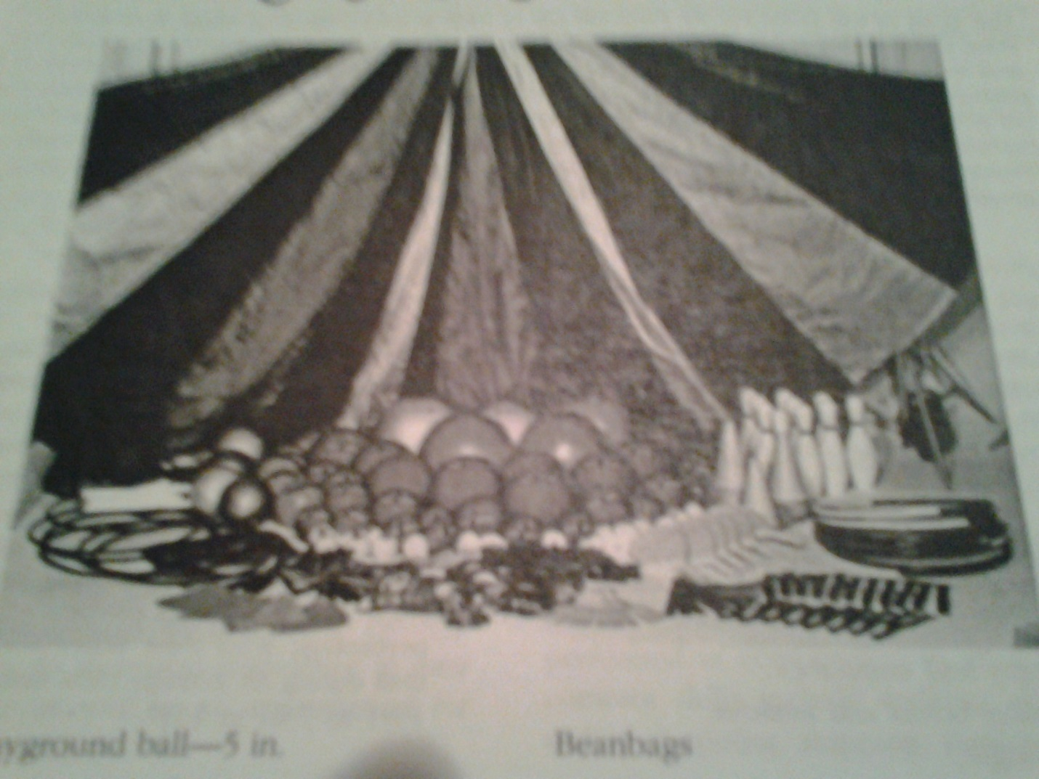

|  |  |  |  |
| --- | --- | --- | --- |
| **Date** | **Equipment** | **Check Out** | **Check In** |
|  | 10 Short tennis rackets |  |  |
|  | 10 Racquetball rackets |  |  |
|  | 10 cones |  |  |
|  | 5 Beach Balls |  |  |
|  | 10 Bouncy Foam Balls |  |  |
|  | 10 SlO MO balls |  |  |
|  | 10 Bouncy Foam Balls |  |  |
|  | 10 Expand –O-Hoops |  |  |
|  | 10 Hula Hoops |  |  |
|  |  |  |  |
|  |  |  |  |
|  |  |  |  |
|  |  |  |  |
|  |  |  |  |
|  |  |  |  |

