# Sport Organization Fair Flyer

## By, Laura K. White- Adapted Physical Education Teacher

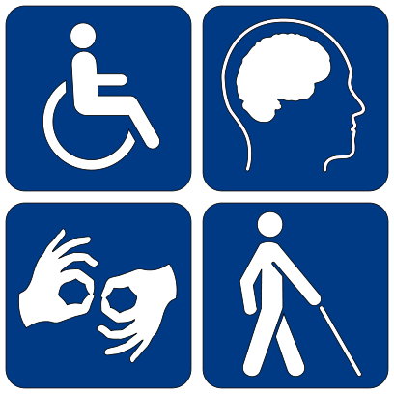 

* Ability First Sports: a 501(C)(3) non-profit organization
  + [www.abilityfirstsports.org](http://www.abilityfirstsports.org)
  + (530) 588-0335 in Chico, California
  + This is for children with physical disabilities.
* [**Adaptive Sports at the Los Angeles Abilities Expo Event**](http://www.abilities.com/losangeles/sports.html)

[www.abilities.com/**losangeles**/**sports**.html](http://www.abilities.com/losangeles/sports.html)

Abilities Expo > **adaptive sports organization** that travels around the country giving Adaptive Sport Expo events

* Adapted Sports Foundation

[www.adaptivesportsfoundation.org](http://www.adaptivesportsfoundation.org)

is located in Windham, NY (518) 734-5070

It offers winter and summer sport programs and supports competitive

racing to children and adults with cognitive and physical disabilities.

* Bay Area Outreach and Recreation Program ( BORP)

www.borp.org

(510) 849-4663

BORP is the leading provider and promoter of adaptive sports and accessible recreation for children and adults with physical disabilities.

It is a 501 (C ) (3) non-profit organization

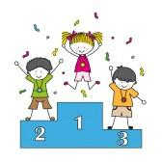

* [**Disability Organizations - NCDJ**](http://ncdj.org/resources/organizations/)

ncdj.org/resources/**organizations**

**is an online disability organizations resource.**

* North American Riding for the Handicapped Association Local Chapters that sponsor adaptive horseback riding [www.pathintl.org](http://www.pathintl.org)
* One Local example of an equine camp:

|  |  |  |  |
| --- | --- | --- | --- |
| * **Move A Child Higher/MACH 1** P.O. Box 41308 Pasadena, CA 91104 (626) 695-2894 [joymach1@yahoo.com](mailto:joymach1@yahoo.com) [www.moveachildhigher.org](http://www.moveachildhigher.org/) |  |  |  |
| * **ACTIVITIES:** Camps (Summer, Day, or Other), Equine Facilitated Psychotherapy, Grooming & Tacking, Ground Work, Therapeutic Riding, Vaulting/Interactive Vaulting, Veterans Programs | | |
| * **DISABILITIES SERVED:** ADD or other Hyperactivity Disorder, Autism, Cerebral Palsy, Developmental Delay or Disability, Down Syndrome, Emotional, Behavioral, or Mental Health, Genetic Conditions/Disorders, Head Trauma/Brain Injury, Hearing Impairment, Intellectual Disability, Learning Disability, Muscular Dystrophy, Paralysis, PTSD, Speech Impairment, Spinal Cord Injury, Visual Impairment | | |

* [**Local Chapters - Disabled Sports USA**](http://www.disabledsportsusa.org/chapters/)

www.**disabledsports**usa.org/**chapters**

DSUSA **Los Angeles** - The Unrecables ... **Disabled Sports** USA is a nonprofit, tax-exempt charitable **organization** under Section 501(c)(3) ...

* [**Disability Sports: Information on Sport for the Disabled ...**](http://www.disabled-world.com/sports/)

**www.disabled-world.com**

News and information pertaining to **disability sports** including Paralympics and disabilities sporting events

* Discovery Blind Sports

[www.discoveryblindsports.org](http://www.discoveryblindsports.org)

Kirkwood, California (209) 258-2233

It is an all-volunteer, 501 (C ) (3) non-profit corporation that promotes

positive awareness and self-sufficiency through sports.

* Very Well Health

www.verywellhealth.com/list

Gerber, Charlotte. *Hobbies for the Disabled,* 3/8/18

List of updated resources for fun and varied hobbies and sports for

all ages.

* [**Wheelchair Sports Federation | Adaptive Sports Organization**](http://wheelchairsportsfederation.org/)

**www.wheelchairsportsfederation**.org

**Wheelchair Sports Federation** is a national non-profit that provides opportunities for the **disabled** and wheelchair-bound adults and youth to play adaptive **sports**

 