Rolling

PE in a Box 3

|  |
| --- |
| **Lessons are from Sport For All - Human Kinetics** |
| **Grades 3-5** |
| Visual cues; such as using words along with a peer tutor will be used for the visually impaired. For those who speak a different language, picture cards are helpful. |
| 1. Solo Roll |
| 1. Partner Roll |
| 1. Roll a Goal |
| 1. Rolling-Keep Away |
| 1. Rolling-Turkey Ball |
| 1. Target Roller |
| 1. Rolling With a Partner |
| 1. Rolling Knockdown |
| 1. On the Move |

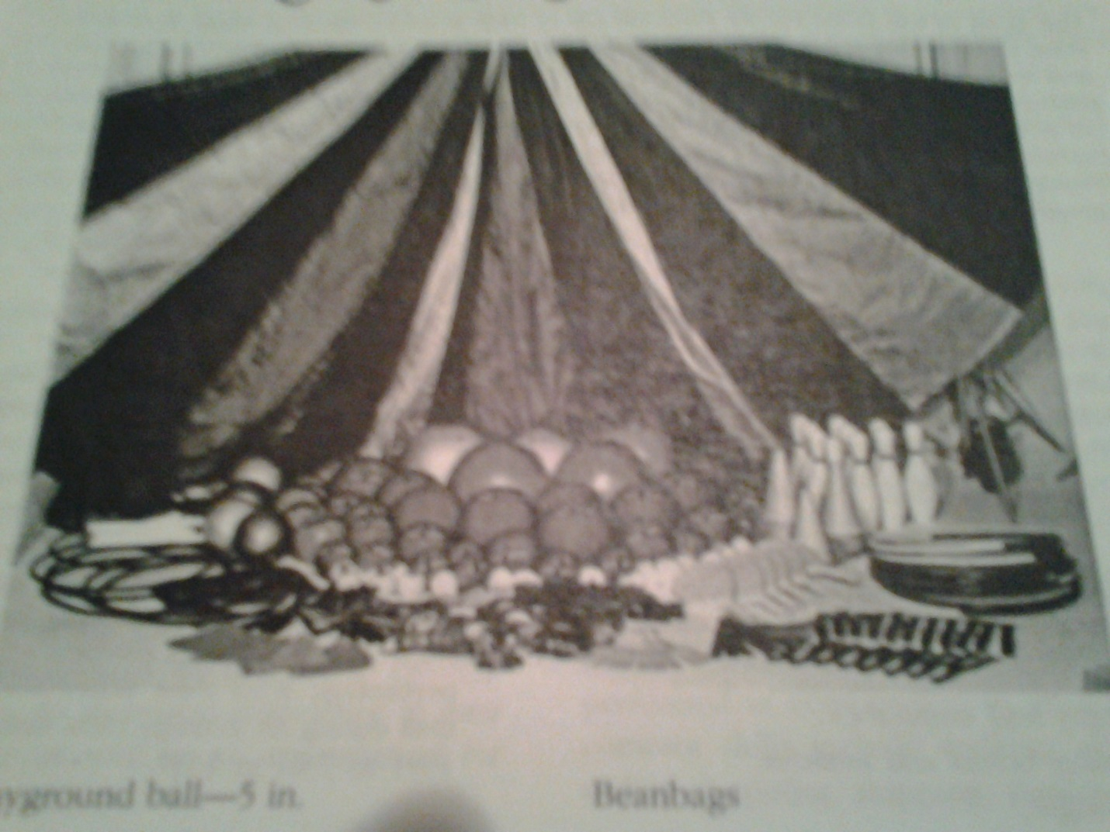

|  |  |  |  |
| --- | --- | --- | --- |
| **Date** | **Equipment** | **Check Out** | **Check In** |
|  | 3 Playground Balls |  |  |
|  | 10 Tennis Balls |  |  |
|  | 10 cones |  |  |
|  | 10 Pins |  |  |
|  | 10 Beanbags |  |  |
|  | 10 Spider Balls |  |  |
|  | 10 Different sized sticks |  |  |
|  | 10 Spot Markers |  |  |
|  | 10 Rings of various sizes and weights |  |  |
|  |  |  |  |
|  |  |  |  |
|  |  |  |  |
|  |  |  |  |
|  |  |  |  |

