Movement & Body Awareness

PE in a Box 2

|  |
| --- |
| **Lessons are from Sport For All - Human Kinetics** |
| **Grades 3-5** |
|  |
| 1. Dancing Body Parts |
| 1. Stop and Go |
| 1. Rabbits |
| 1. Statues |
| 1. Up and Down |
| 1. Moving Fast/Slow/High/Low |
| 1. Ice Skating |
| 1. Tightrope |
| Visual cues; such as using words along with a peer tutor will be used for the visually impaired. For those who speak a different language, picture cards are helpful. |

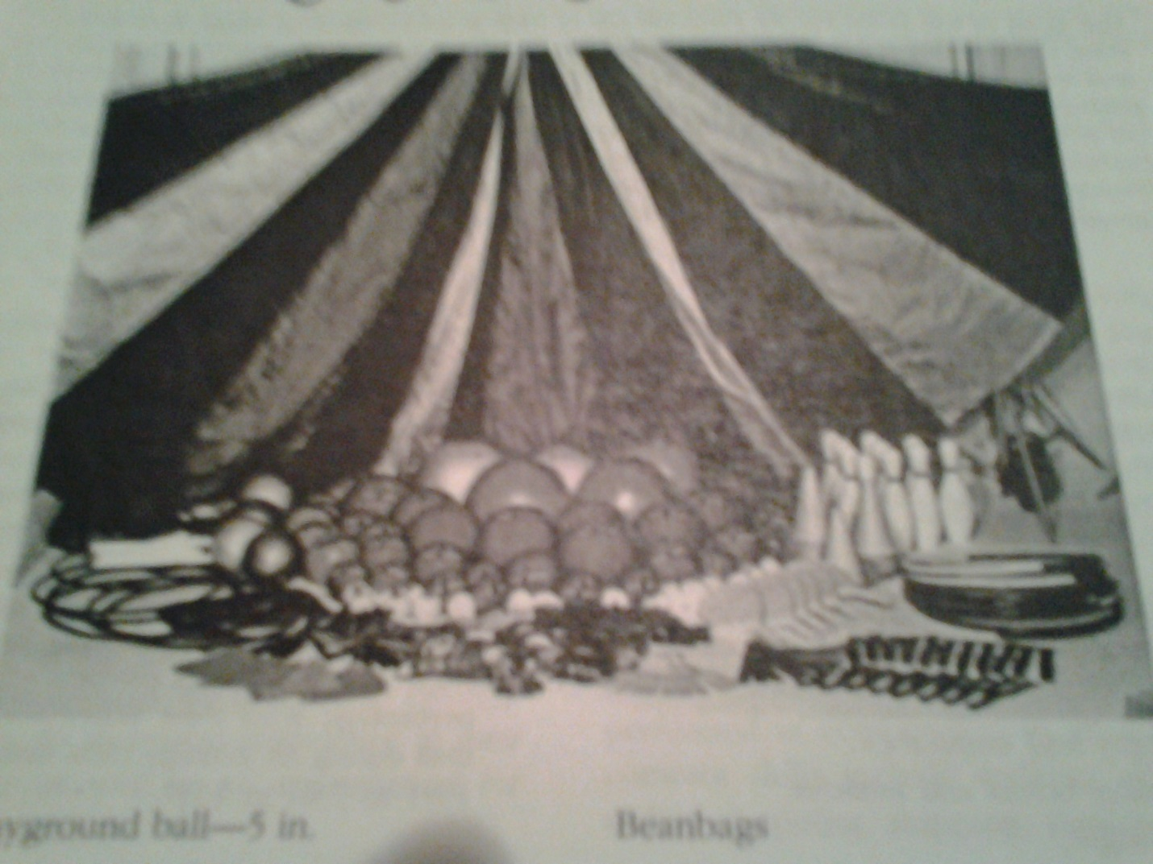

|  |  |  |  |
| --- | --- | --- | --- |
| **Date** | **Equipment** | **Check Out** | **Check In** |
|  | 10 Spot Markers |  |  |
|  | 10 Shelf Liner Lines |  |  |
|  | 10 cones |  |  |
|  | 10 Koosh Balls |  |  |
|  | 10 Beanbags |  |  |
|  | 20 Paper Plates |  |  |
|  | 1 CD Player |  |  |
|  | 1 Music CD |  |  |
|  |  |  |  |
|  |  |  |  |
|  |  |  |  |
|  |  |  |  |
|  |  |  |  |
|  |  |  |  |



