Locomotive & Rhythm
PE in a Box 5
Lessons are from Sport For All - Human Kinetics
Grades 3-5
- Animals

- Bouncing

- Climbing

- Beans

- Four Corners

- Sticky Bits

- Musical Scarves

- Scarf Juggling

Visual cues; such as using words along with a peer tutor will be used for the visually impaired. For those who speak a different language, picture cards are helpful.

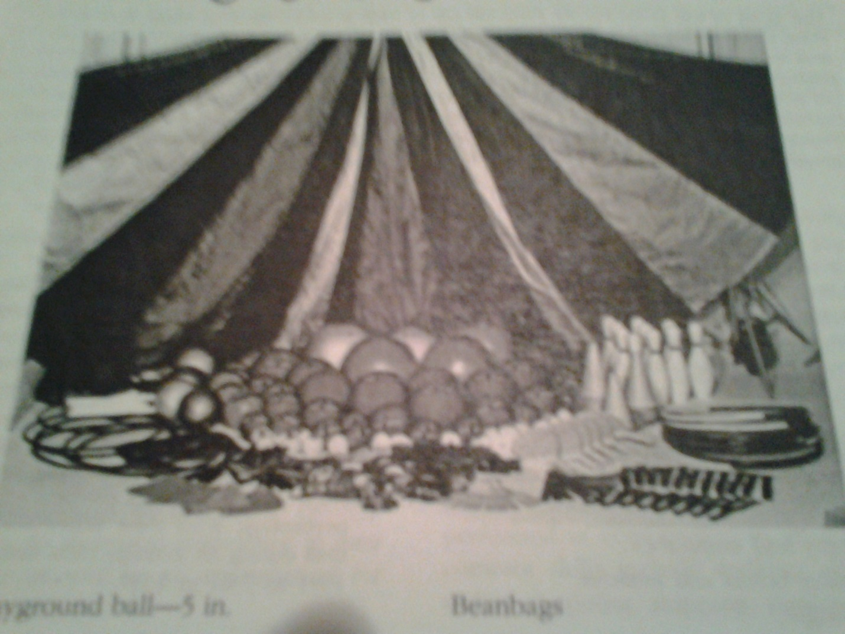

Date | Equipment | Check Out | Check In
 | 10 Spot Markers
 | 10 Jump Ropes
 | 10 Playground Markings
 | 10 PVC-covered foam shapes
 | 1 Play Tunnel
 | 1 brightly colored tape roll
 | 10 cones
 | 8 Movement Signs
 | 1 CD Player
 | 1 Music CD
 | 10 beanbags
 | 10 Throwing Rings
 | 10 Different sized balls
 | 10 Brightly colored scarves

