Kicking
PE in a Box 4
Lessons are from Sport For All - Human Kinetics
Grades 3-5
- Kicking-On Your Own

- Kicking With a Partner

- Kicking Targets

- World Cup Goalkeeper

- Runaround

- Kick Squash

- Rogueball

- ABC Kick

Visual cues; such as using words along with a peer tutor will be used for the visually impaired. For those who speak a different language, picture cards are helpful.

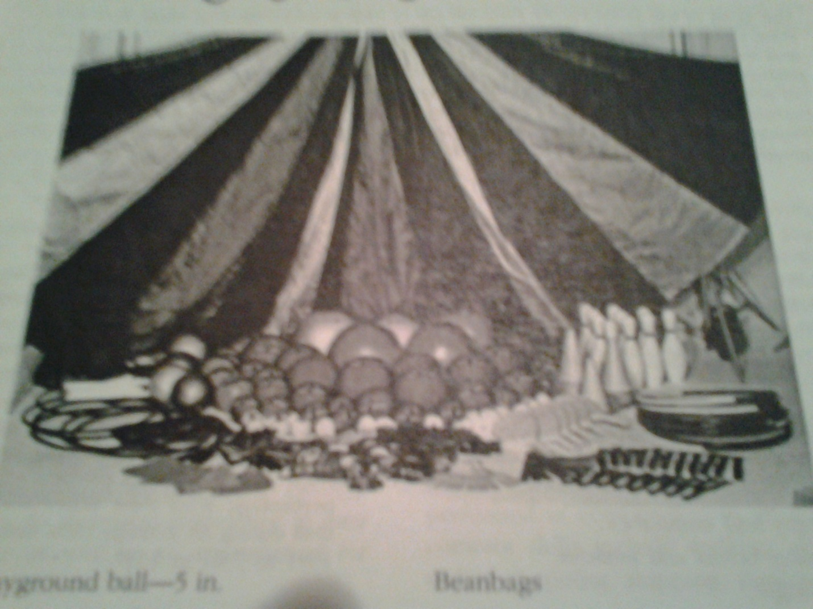

Date | Equipment | Check Out | Check In
 | 10 Shelf Liner Lines
 | 10 Large Balls
 | 10 cones
 | 5 Beach Balls
 | 10 Bouncy Foam Balls
 | 10 SlO MO balls
 | 10 Bouncy Foam Balls
 | 10 Expand –O-Hoops
 | 10 Hula Hoops
 | 10 Buckets for targets
