Blind Childrens Center
4120 Marathon Street
Los Angeles, CA 90029
(323) 664-2153 (Local)
(323) 665-3828 (Fax)
(800) 222-3566 (Toll-Free)
info@blindchildrenscenter.org
http://www.blindchildrenscenter.org
Services for Children: Assessment/Education Services/Pre-School Programs/Support Groups/Travel/Orientation and Mobility and much more.
Extreme Mobility Camps
3578 Claridge Court
Simi Valley, CA 93063
(805) 501-7231 (Local)
(805) 539-6039 (Fax)
xmocamps@gmail.com
http://www.xmocamps.org/
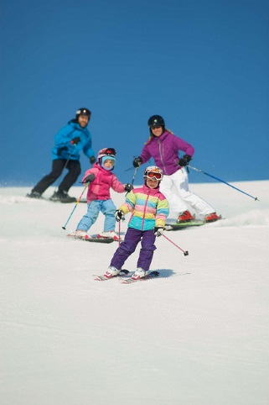
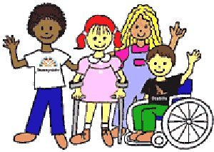

Services for Children: Summer/Day Camps and After-school Programs
We use “extreme” sports to empower blind/visually impaired athletes and volunteers. (ages 13-30) who are blind/visually impaired or have other disabilities. These camps are offered at no charge to the participants. We offer snow-skiing/boarding, cross-country skiing, driving a snowmobile, screaming down the tubing hill, or enjoying a sleigh ride in our winter camping program. One of our summer camps includes surfing, wake boarding, water skiing, tubbing, jet skiing and getting a full California experience. Another camp exclusively for the athletes who are capable includes summiting and backpacking to the top of Mt. Whitney.

Junior Blind of America
5300 Angeles Vista Boulevard
Los Angeles, CA 90043
(323) 295-4555 (Local)
(323) 296-0424 (Fax)
(800) 352-2290 (Toll-Free)
info@juniorblind.org
http://www.juniorblind.org
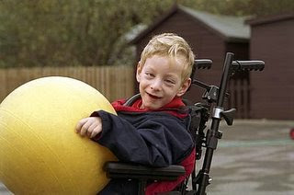

Services for Children: Based in Los Angeles, Junior Blind offer specialized services for thousands of infants, children, teens, and adults from throughout California and across the country. Through programs that offer early intervention therapy, education, recreation, and rehabilitation, children and adults learn essential skills to help them maximize their potential and achieve their goals.
I Can Bike
821 Baxter St. Suite 310
Charlotte, NC 28202
(704) 910-4512
e-mail: info@autismcharlotte.org
website: www.icanshine.org

Brief Description: The iCan Bike Camp (formerly Lose the Training Wheels™) is a national program that utilizes highly trained coaches and technicians, uniquely adaptive equipment, a proven methodology and scores of volunteers to assist each child. It is a week-long camp that teaches children with a variety of disabilities to ride a conventional two-wheel bike.

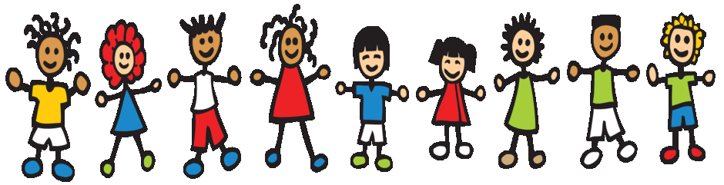

Camp Abilities Brockport
350 New Campus Drive
Brockport, NY 14420
(585) 395-5361

Mission: The mission, or purpose, of Camp Abilities Brockport is to empower children and teens with visual impairments to be physically active and productive members of their schools, towns, cities, and communities, as well as to improve the health and well-being of people with sensory impairments.
Services for Children: Canoeing/rollerblading/tandem biking/horseback riding/rock climbing/swimming/ track and field and many more.

Karate For All
3002 Dow Ave. #114 Tustin, CA 92780
27341 Trabuco Circle Mission Viejo, CA 92692
714-731-4668
http://www.karateforall.org

Brief Description: Karate For All is a Community Occupational Therapy based Martial Arts Program in Orange County, developed specifically for children and adults with special needs. Using Occupational Therapy knowledge and skills, KFA combines the discipline of martial arts to achieve motor, cognitive, social and processing goals.

Reid’s Gift
16639 Cantlay St. Van Nuys, CA. 91406
(310) 853-0794
www.reidsgift.org
- Ages 14+ with special needs
- 10am – 3pm Monday through Friday
- $300/week

Brief Description: Activities include swimming, sports, music, arts and crafts, yoga, dance, and social skills.

AHEAD With Horses
10157 Johanna Avenue Shadow Hills, CA 91040
(818) 767-6373
www.aheadwithhorsesla.org

Brief Description: AHEAD WITH HORSES has an over 45-year history of providing unique, highly motivating and effective therapy, education and recreation through horses and related experiences to disabled, disadvantaged, at-risk and special-needs children and has earned recognition educationally, medically and scientifically.

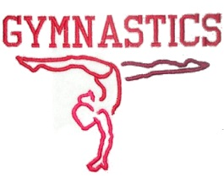
Big Fun
3710 S. Robertson Blvd, Ste 225 Culver City, CA 90232
310-837-7849
Big Fun Gymnastics
Ten locations throughout Southern California.

Brief Description: BIG FUN is the ultimate playground for special needs individuals of all ages. They offer families throughout southern California occupational therapy services, gymnastics, swimming, after-school enrichment programs, social skills, camps, art classes, parent and me, activities for autistic children, social skills training for autism, and more.

MDA Summer Camp
Los Angeles MDA office (310) 390-6802
Locations: Throughout California and the US. Check their website for specific listings
http://mda.org/summer-camp
Brief Description: MDA camp offers kids with neuromuscular disease a fun and safe outdoor experience, along with opportunities to engage in a variety of activities such as horseback riding, swimming, adaptive sports, arts and crafts, camp dances and much more.

